

**SBDR CHAINSAW RECOVERY MANUAL**

**Revised: Revision January 2020**

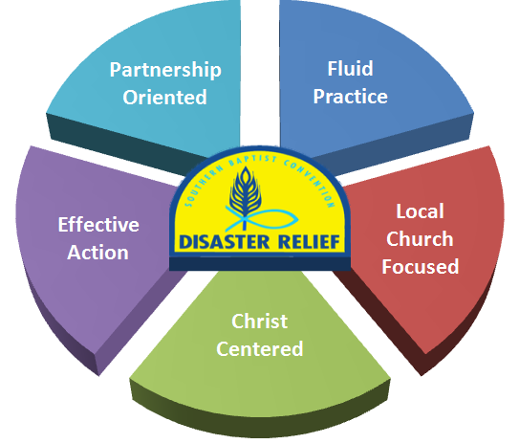

**Vision Statement:**

Southern Baptist Disaster Relief will be a well-defined, unified disaster response organization, demonstrating the love of Christ by providing physical and spiritual help to those affected by disasters.

**Mission Statement:**

Southern Baptist Disaster Relief is a Christ-centered partnership of national, state and associational ministries serving through the local church to bring **help**, **healing** and **hope** to individuals affected by disasters.

**Table of Contents Page**

**Introduction 1**

**Bible Verses 1**

**Section 1: General Information**  1

Work Request Priorities 1

Chainsaw Ministry 2

Heavy Equipment 2

Before You Go 2

What to Bring 2

Parts of a Chainsaw 3

**Section 2: Unit and Team Structure 3**

Chainsaw Unit 3

Unit Leader (Blue Cap) 3

Team Members (Yellow Cap) 4

General 4

Daily Meetings 4

**Section 3: Site Evaluation and Setup 4**

Arrival 4

Setup 4

Start of Work 4

Completion of Work 5

**Section 4: Chainsaw Safety 5**

Safety 5

Clothing and Gear 5

Injuries 6

**Section 5: Operation Safety 6**

General 6

Operating Saw 6

Gear 6

Planning 6

Work Area 6

Wood Under Pressure 7

Blow Down areas 7

**Section 6: Chainsaw Operation 7**

Starting 7

Cutting 8

Pinched Saw 8

Carrying Saw 8

“Chain” Rules of Thumb 8

**Section 7: Basic Chainsaw Cuts 9**

Open Face Felling 9

Putting It All Together 10

Limbing 11

Bucking 11

Wood Under Pressure 11

**Table of Contents Page**

**Section 8: Chainsaw Maintenance 11**

General 11

Procedures 12

**Section 9: Develop Your Skills 12**

Courses 12

Websites 12

**Appendices 13**

Suggested Equipment 13

Property Owner’s Request Form 15

Assessment – Chainsaw Form 16

Assessment – Property Area Form 17

Safety Precautions

ANSI B 175.1(Attachment 2) 18

Additional Notes 19

**Note: Illustrations in this manual are from “To Fell a Tree”, 2009 by Jeff Jepson and are used by permission of Jeff Jepson.**

**Introduction**

* Southern Baptist Disaster Relief (SBDR) is a Christ-centered partnership of national, state and associational ministries serving through the local church to bring **help**, **healing** and **hope** to individuals affected by disasters.
* SBDR began in Texas in 1967 and has grown to be one of the largest and most respected disaster organizations in the U.S. and around the world. Chainsaw Recovery is a vital component of the Disaster Relief Recovery Ministry.
* This Chainsaw manual provides a brief overview of the safe operation of a chainsaw and chainsaw team. As with any equipment, the operator should seek to gain as much knowledge and skill as possible about operating a chainsaw.
* In addition, a chainsaw volunteer should spend time in hands-on training practicing the procedures and skills taught in this manual. It is recommended that this training contain a minimum of eight (8) hours for classroom and practical training.
* This training is recommended for every SBDR volunteer serving on a chainsaw team.

**Bible Verses**

Unless otherwise noted, all scriptures are taken from the Christian Standard Bible copyright 2017 by Holman Publishers (HCSB). Used by permission.

**Galatians 6:9-10**

9So we must not get tired of doing good, for we will reap at the proper time if we don’t give up. 10Therefore, as we have opportunity, we must work for the good of all, especially for those who belong to the household of faith.

**Philippians 2:13**

13For it is God who is working in you, enabling you both to desire and to work out His good purpose

**Matthew 25:40**

40“And the King will answer them, ‘I assure you: Whatever you did for one of the least of these brothers of Mine, you did for Me.’

**Ephesians 4:2**

2with all humility and gentleness, with patience, accepting[[a](https://www.biblegateway.com/passage/?search=Ephesians+4%3A2&version=HCSB#fen-HCSB-29273a)] one another in love

**Section 1: General Information**

**Work Request Priorities**

* Every work request is assigned a Priority by the Assessment team to aid the IMT in prioritizing the work. The priority is generally based on the people and circumstances and not necessarily the work. The work of the Chainsaw team is the same regardless of the work request Priority. Remember, we are here to minister to hurting people which sometimes will override all other priority issues.

**Chainsaw Ministry**

* The chainsaw ministry cuts up and removes trees from houses, driveways, and other locations impacted by a disaster.
* The Chainsaw ministry removes trees that pose a danger to the home or the work team. Chainsaw teams, with the appropriate training, work on the ground, on ladders, and on roofs,
* With the aid of Heavy Equipment and climbers, remove high dangerous limbs.

**Heavy Equipment**

* Heavy Equipment including tractors, skid steers and man-lifts are integral parts of a chainsaw unit.
* Heavy Equipment can be stand-alone units supporting the chainsaw unit or simply another chainsaw tool.
* Skid Steers and tractors are used to pick up and move heavy logs, provide tension in the rigging process to ensure a tree falls in the desired direction, and used to pick up and move debris.
* Man-lifts are used to reach high hanging limbs without having to use climbers.
* The use of Heavy Equipment increases the efficiency of a chainsaw unit and allows the completion of additional work requests.

Before You Go

* Have a humble servant spirit
* Prepare spiritually and mentally
* Recognize severity of situation
* Be prepared to work long, hard hours under difficult conditions
* Know your physical limits
* Be prepared to share the Love of Jesus
* Be a Team Player
* Remember - God deserves all the credit

**What to Bring**

* Bible, devotional and reading material
* Keep a Journal
* Personal care items, towels, wash cloths etc.
* Full sleeping gear
* All medications and insurance card
* Good sturdy comfortable boots
* Insect repellent and sunscreen
* Flashlight
* Work clothes (seasonal)
* Comfortable clothes for after work hours
* Sleep wear
* Cell phone and charger

**Parts of a Chainsaw**

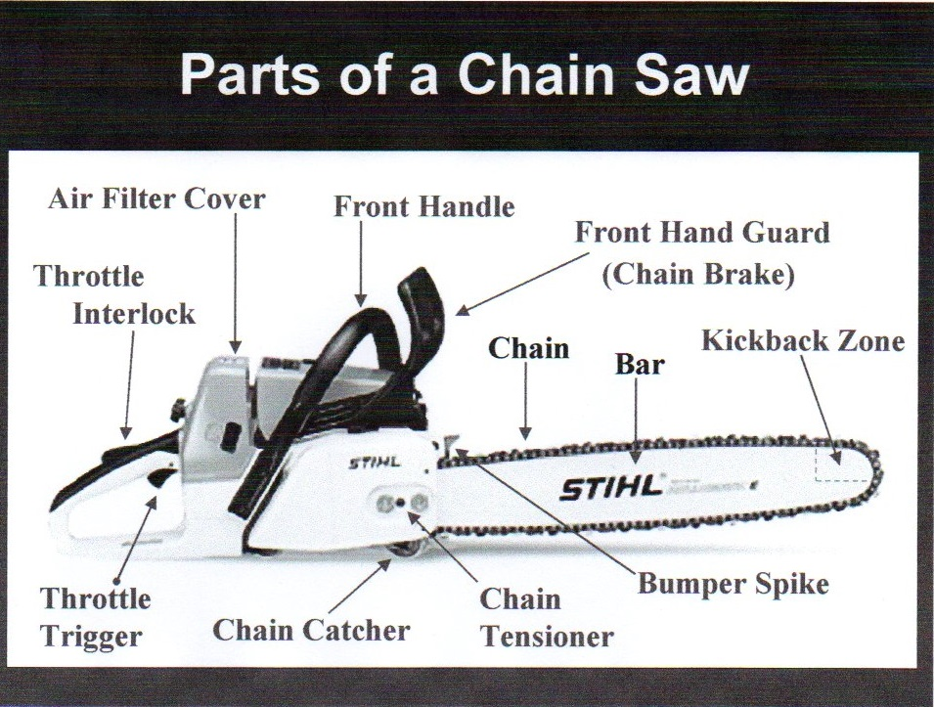

**Section 2: Unit and Team Structure**

Chainsaw Unit

* It is recommended that the chainsaw unit be a towable trailer. This will allow different vehicles to pull the unit. It also reduces the insurance requirements for the unit and increases the number of drivers available. The size of the trailer will depend on the amount and weight of equipment and the capabilities of the team.

**Unit Leader (Blue Cap)**

* The Unit Leader should be an experienced Chainsaw volunteer who has completed the designated Unit Leader and basic chainsaw training and wears the Blue Cap for easy recognition of leadership of the team.
* The Unit Leader is responsible for all team activities during deployment and for the safety of all volunteers, homeowners, and homeowner’s personal property at the work site.
* The Unit Leader should participate in a daily briefing with the IMT to receive the latest information related to the chainsaw recovery operations and receive work requests.
* Review “Assessment – Chainsaw”, “Property Owner’s Request”, and “Assessment – Property Area”, prior to beginning work.
* Confirm address and have owner sign the “Property Owner Request” if it has not been signed.
* Be an individual that knows that it is “All about Jesus” and has a positive Christian walk.

**Team Members (Yellow Cap)**

* All team members should wear a yellow hat, no matter his/her training or qualifications.
* Yellow cap team members are an integral part of the overall safety and success of the team.
* When in doubt – ask the Blue Cap.
* Be an individual that knows that it is “All about Jesus” and has a positive Christian walk.

**General**

* Be flexiblein the assigned tasks and ready to make adjustments. It is difficult to adequately list all tasks. Teams should be prepared to meet existing needs.
* Remember, “It is not about production, it is about your testimony.” Flexibility is the key to success. Remember also that every assignment could be an opportunity to share the love of Jesus Christ.
* Be informed. Deal with information in a positive way. Never be part of misinformation.
* Be responsive in an intelligent, careful, supportive and effective manner.

**Daily Meetings**

* Teams will meet for devotion and debrief each day. This leads to better team effectiveness and communication.
* Morning devotion (10 to 15 minutes) may be led by team chaplain or team member, or could be led by the Incident Commander (White Cap) for the entire operation.
* Evening debrief, may be led by the White Cap for the entire operation, if not debrief should be led by the Unit Leader and should include a time of devotion and prayer.
* Prayer time should include the disaster survivors, the Recovery Operation, and your individual team and team leaders.

**Section 3: Site Evaluation and Set Up**

**Arrival**

* Determine best location for trailer and supporting equipment.
* Pray over the site and with homeowner.
* Determine and discuss any onsite hazards and the overall plan for the site.
* Designate two (2) people to call for help if needed.
* Designate First Aid person

**Set Up**

* Set up water, snack, First Aid, and rest locations.
* Determine/setup sanitation station.
* Blue Cap reviews Work Request with homeowner
* Blue Cap assigns tasks to team.
* Team determines location of debris, logs, brush, etc. piles.

**Start of Work**

* Start assigned task.
* Watch out for each other, safety is key.
* Take breaks as needed.

**Completion of Work**

* Review completed work with homeowner
* Clean tools and reload unit
* Pray and present Bible to Homeowner

**Section 4:** Chainsaw Safety

**Safety**

* Being mindful of your surroundings at all times.
* A set of rules to follow.
* An Attitude of Safety

**Clothing and Gear**

* Personal Protective Equipment, (PPE) **requirements** include proper clothing and footwear; hand, leg (chaps), head, ear, and eye protection. All PPE should be inspected before each use.
* Clothing must not be loose fitting. Loose-fitting clothing could become tangled in brush and limbs as well as the saw. Anything that could become entangled must be secured before operating a saw. Short pants or shorts are not allowed.
* 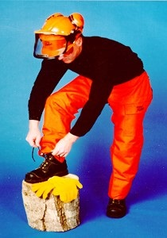Proper footwear is also important. Chainsaw protective leather boots with high tops, arch and ankle support, and crush resistant toes are recommended. Tennis shoes, sneakers, or low-cut hiking shoes are not permitted.
* A key part of the PPE are the **chaps**. Chaps are constructed of material that resists cuts from the saw teeth. The internal material chokes the saw to a stop when entangled.
* Chainsaw gloves are preferred. They are constructed of a material that resists saw cuts to the hands in the event of a kick back. Gloves provide a better grip and reduce fatigue caused by extended operation.
* The chainsaw helmet provides protection to the head. It includes a pull-down eye shield and ear covers to reduce noise. The recommended chainsaw helmet must have a 6- or 8-point interior harness system.
* Cracked helmets or helmets with defective shields, harnesses, or ear protection should not be used. OSHA recommends that all harnesses be replaced after 2 years from initial service
* Helmets (Hard Hats) are required for anyone in the work (Chainsaw) area.
* Each chainsaw unit must have the required PPE for each person operating a chainsaw (Appendix). These items include helmets with eye and ear protection, gloves, and chaps. **PPE must be worn whenever you are operating a chainsaw.**
* It is recommended that all cutters have a small tool pouch which could hold wedges, chainsaw tool, file, and first aid supplies
* If cutting in trees, on ladders, man lifts, or roofs, appropriate fall protection must be worn and secured to an anchor point.

**Injuries**

* Head Area 7.5%
* Upper Body 3.6%
* Arms & Hands 38.9%
* Leg injuries 41.6%
* Foot injuries 8.3%

Remember the saw blade is traveling in excess of 80 feet per second. Just a touch can result in serious injury in as little as a split second. Review these safety tips **before** operating a chainsaw.

**Section 5: Operation Safety**

**General**

* Read and understand the owner’s manual for the model saw you will be using.
* Watch what you are doing. Use common sense.
* Keep a watchful eye for potential hazards.
* When chain becomes dull, replace with sharp chain.

**Operating Saw**

* Do not operate a chainsaw when you are tired.
* Use a chainsaw for cutting wood only. Do not use it on things for which it is not intended, such as cutting plastic, masonry, etc.
* Only well-trained volunteers should operate a chainsaw. Never allow anyone under age 18 to operate a saw.
* Do not operate a chainsaw:
* While under the influence of alcohol, medication or drugs
* Within 10 feet of highly flammable liquids or gases
* While in a hurry
* While in tree or on a ladder unless trained to do so

**Gear**

* Check all PPE and personal clothing for mobility and safety.
* Wear **ALL** PPE when operating a chainsaw.

**Planning**

* Before cutting make sure you have the following:
* Clear work area of loose debris and trip hazards.
* Secure footing
* Planned retreat path from falling tree (safest route is a 45-degree angle to the rear)
* Inspect the tree carefully before cutting it down. Make sure there are no dead limbs or branches that may fall on you.

**Work Area**

* Stay alert. Use common sense while operating a chainsaw
* Keep work areas clean. Cluttered areas invite injury
* Be aware of local poisonous plants. Poison ivy, poison oak, and poison sumac are the most common poisonous plants in the United States.
* Keep children, animals, and bystanders away from the chainsaw. Only chainsaw operators should be in the work area.
* When felling a tree, have an observer watch for danger. The observer should be close enough to tap the chainsaw operator on the shoulder (use stick or ax handle)
* Do not allow anyone else within **ten feet** of the chainsaw operator.
* If two or more people perform felling operations at the same time, provide plenty of distance between operations. Provide a distance of at least twice the height of the tree being felled.
* If the work area is sloped, work on the hill side when bucking logs or tree felling as much as possible. Working on the downhill side could put the saw operator or other workers in the line of rolling log or felled trees.

**Wood Under Pressure**

* When cutting a limb that is under tension, be alert for spring back.

**Blow down areas**

* Working in blow down areas is extremely hazardous. When bucking a wind-blown tree, you will reach a point where the exposed roots and attached soil may fall back into the hole crushing anyone, or anything in the way.

**Section 6 – Chainsaw Operation**

**Starting**

* Only use OSHA and manufacturer recommended methods for starting chainsaws. Never attempt to drop or throw start a chainsaw. The drop or throw method requires one point of control and causes the saw to be pushed at the leg of the operator.
* Before starting the chainsaw, make sure the chain is not touching anything and that the chain-brake is set.
* To start a chainsaw:
* Ground Method - Set it on the ground, place your foot on the handle, and pull the start cord. Do not start a chainsaw while holding it with one hand.

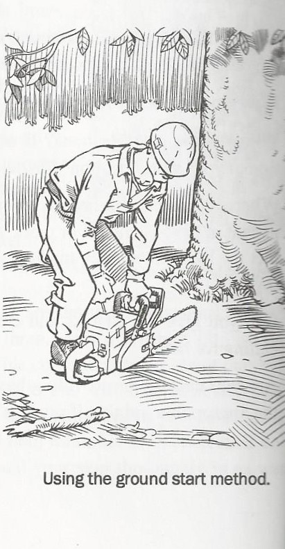

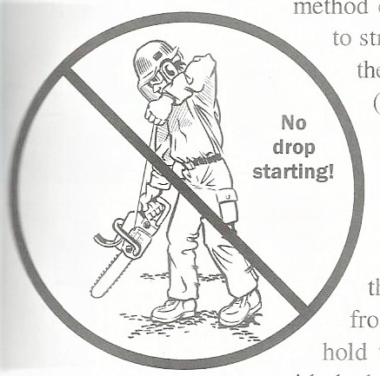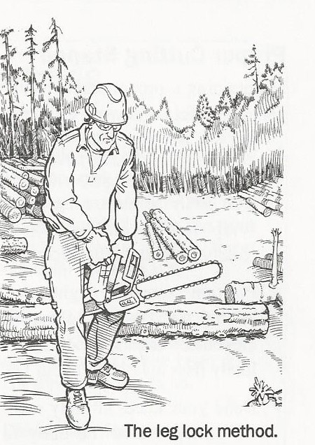

* Leg Lock Method – Engage the Chain Brake. Left hand grip on front handle. Arm straight. Rear handle between legs just above knees. Stay on level ground with secure footing. Right-hand pull-on starter cord until it starts.
* Grip the chainsaw firmly with both hands. Never operate a chainsaw with one hand. Never use the hand guard as a handle.
* Stand at the side of the saw, not behind it, and keep your feet well braced and body balanced.
* Warm up the saw by revving slightly. Make sure the chain is moving appropriately and is not too tight or loose.

**Cutting**

* Keep fingers off the trigger until ready to make a cut.
* Keep all parts of your body away from the chain when the chainsaw is running.
* Run the engine at full throttle.
* Do not force the chainsaw while cutting. Apply light pressure. It will do the job more safely and effectively if it is used at the rate for which it was designed.
* Cut small brush and saplings with extreme care. Slender/Splinter material may catch in the chain and be whipped toward you. This could also pull you off balance.
* When cutting limbs or tree trunks that are under tension, use extreme caution. Be alert for wood springing back. When wood tension is released, limbs could spring back and strike the operator, causing severe injury or death.
* Never operate the chainsaw over your head.
* Try to keep the bar out of dirt and sand.
* When moving with the chainsaw, apply the chain brake before taking more than two steps.
* When not cutting, the chain brake should always be engaged.

**Pinched Saw**

* Should the saw become pinched, turn the saw off before trying to remove it from the tree.
* Have wedges and a sledge hammer close by to un-pinch a saw.
* 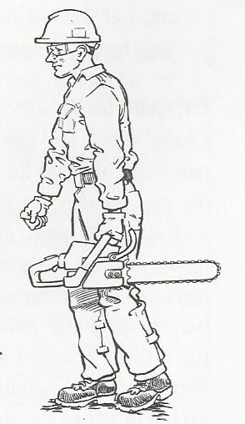While bucking, if the saw becomes pinched, turn saw off and have a team member provide assistance.

**Carrying Saw**

* To carry the chainsaw from one place to another:
* Turn the saw off.
* Engage the chain brake.
* Hold the front handle (never use hand guard as a handle). The bar should face the rear.

**“Chain” Rules of Thumb**

* Avoid hitting rocks, dirt, or other abrasive material
* Check chain tension frequently
* Never force a dull chain to cut
* Never install a new chain without checking the sprocket
* Always wear gloves when handling chain

**Section 7 – Basic Chainsaw Cuts**

**Open-Face Felling**

* **Points to Consider Prior To Felling**
* Hazards
* Good side/bad side
* Escape route
* Hinge
* Cutting techniques
* **Hazards**
* Dead trees and limbs
* Widow makers (hangers)
* Forked trees
* Vines
* Wind
* Ice/snow load
* Other hazards common to your area must be identified and evaluated.
* **Good Side/Bad Side**
* Bad Side:
* The side of the tree that has greater lean and weight
* The side of the tree that we want to start on
* Objects, structures or power lines in the way

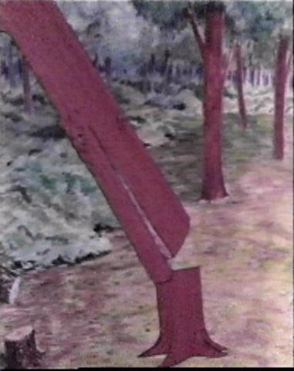

* Good Side:
* Always finish on the good side of the tree
* **The Open-Face Notch**
* The function of the notch is to allow the tree to fall without breaking the hinge prematurely.
* Notches less than 70 degrees close-up before the tree has fallen to the ground. Stress is put on the hinge causing fiber pull, splitting of the butt log or barber chairing.
* 70-90 degrees is a proper notch
* Always start with the top cut. Work downward and slightly inward until the depth of the notch is approximately 1/3 of the diameter of the tree.
* Finish the notch by making the second cut slightly upward or parallel to the ground
* **Advantages to Top Cut First:**
* Easily establish hinge length
* Can look into top cut and actually see second cut
* Eliminates by-pass which is hazardous
* Allows for use of sight-line found on many chainsaws
* **The Hinge**
* The Hinge is the single most important part of the felling cut.
* The hinge controls:
* Felling direction
* Reduces the chance of hang-ups

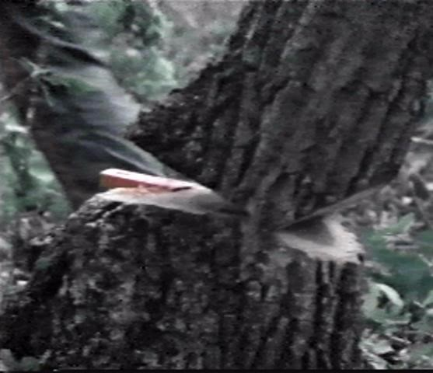

* Hinge thickness should be the same all the way across the stump.
* **The Hinge Length**
* Should be approximately 80% of the diameter of the tree. A 10” tree should have a face cut of 3-4” into the tree to give a hinge length of 8”.
* **Hinge Thickness**
* Should be even all the way across and as a rule of thumb should be 10% of the diameter of the tree. A 10” tree = 1” hinge, however, you must adapt thickness to the species and area you are working in. Weather conditions can also affect the hinge.

**Putting it all Together:**

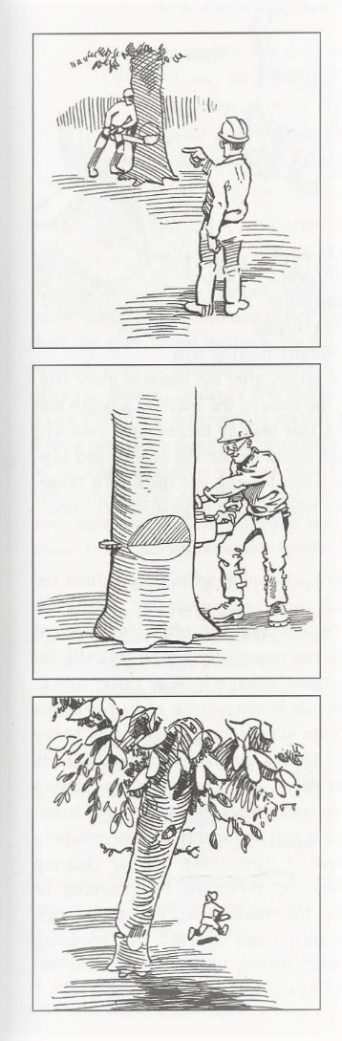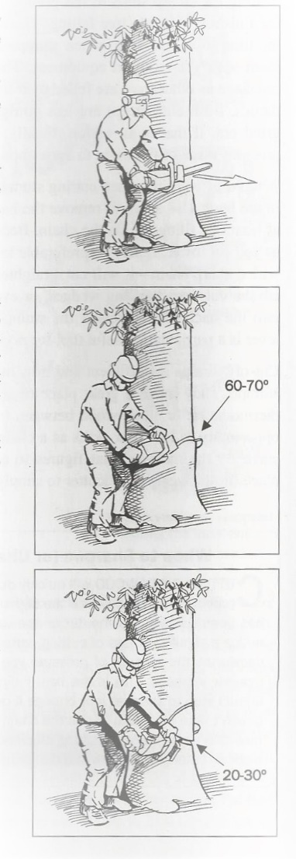

**Limbing**

* Keep your feet approximately shoulder width apart
* Try to keep a balanced, comfortable stance to reduce fatigue and maximize saw control
* Keep right hand around rear handle, left hand around front handle
* Be aware of the possibility of kickback—avoid working with the tip of the bar
* Do not stand on the tree
* Stand on the uphill side
* Normally work from the base of the tree toward the top
* Work from the outside in
* Work from the lower branches to the higher ones
* Leave the branches that are supporting the log until last to prevent dangerous shifting

**Bucking**

* Do not stand on the log
* Make sure the log will not roll downhill
* If on a slope, stand on the uphill side of the log
* Determine where the tension and compression forces are located at the bucking point. Incorrect judgment often results in pinched saw bars.
* Watch the saw kerf -- is it opening, closing or twisting?
* Proper use of wedges can prevent pinching and reduce cutting time
* If the saw becomes pinched DO NOT jerk or try to muscle it out. Trying to do so often results in bent bars that have to be discarded.

**Wood Under Pressure**

* When cutting a limb that is under tension, be alert for spring back so that you will not be struck when the tension in the wood fibers is released.

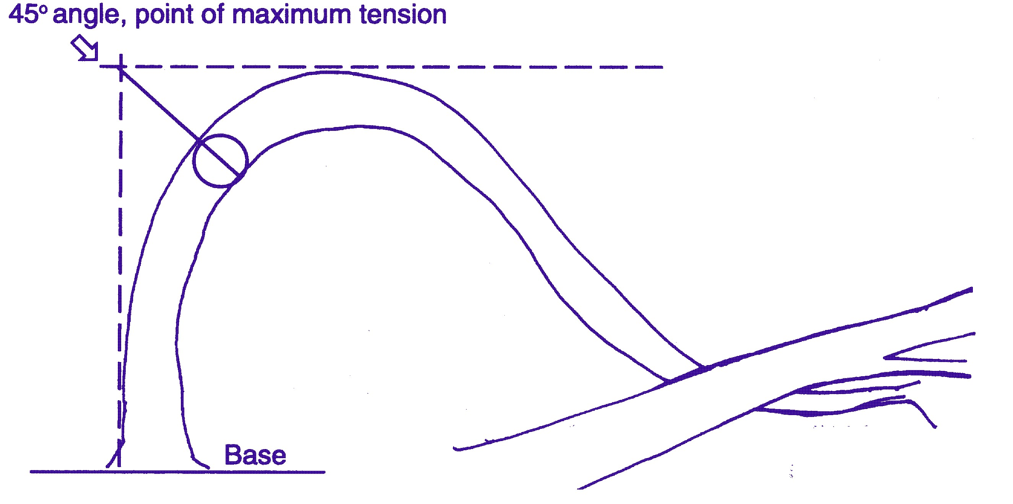

**Section 8: Chainsaw Maintenance**

**General**

* The performance of your saw can make the difference between a good day and a bad day in the field. There is nothing more frustrating, than a saw that does not operate properly once you are in the field and ready to go to work. Maintenance is very important.
* Maintenance should be performed at the unit or preferably in a shop where a vise and adequate space are available. A unit with built in work space is an essential part of the maintenance of chainsaws.
* The field is not the appropriate place to do maintenance unless absolutely necessary. If maintenance must be performed in the field, find a clear area and spread a tarp on the ground so smaller parts will not get lost.
* Use branded fuel only (89 Octane or better, preferably no alcohol)
* Mix only what fuel will be used in 45 days.

**Procedures**

* Do a visual inspection of the complete saw.
* Clean the air filter. Replace if needed.
* Check the carburetor horn for debris before reassembling air filter.
* Inspect the spark plug.
* Check the starter cord.
* Check the flywheel.
* Inspect the clutch drum and drive sprocket.
* Inspect the brake band for wear, and cracking
* Clean the chain and bar.
* Inspect the chain and properly tighten as needed. Replace chain if dull.
* Inspect muffler and spark arrestor screen.
* Periodically check all bolts, nuts, and screws for proper torque.

**Section 9: Develop Your Skills**

**Courses**

* First Aid
* CPR courses
* Disaster awareness emphasis: church, association
* Practice sessions: tools and power equipment
* Advanced chainsaw training (climbing, rigging)

**Websites of Interest:**

* [www.stihlusa.com](http://www.stihlusa.com)
* [www.husqvarna.com](http://www.husqvarna.com)
* [www.fs.fed.us](http://www.fs.fed.us)
* [www.ext.nodak.edu](http://www.ext.nodak.edu)
* [www.ksre.ksu.edu](http://www.ksre.ksu.edu)
* www.namb.net/dr
* [www.training.fema.gov](http://www.training.fema.gov/) (for IS-100, 200 and 700 courses)

**APPENDICES**

**Suggested Equipment for Chainsaw Units**

**General**

* Bibles or New Testaments
* Hope in Crisis tracts
* Fire extinguisher
* First aid kits (main kit on the unit, plus one per crew working separately). All first aid kits should have compression bandages.
* Book: To Fell a Tree, by Jeff Jepson
* Ice Chest
* Gas cans for raw gas and mixed gas. (5 gallon can for unmixed fuel and 1-gallon cans for mixed fuel)
* Tool Box with Basic tools

**Safety**

* Chaps for each saw operator
* Helmets with ear muffs and face shield for each saw operator
* Safety Helmets for all workers not operating a saw
* Ear-plugs available for other workers
* Safety goggles and/or safety glasses
* Work gloves

**Equipment**

* Chainsaws (at least 4) - minimum 16” bar
* Power Pole saw
* 2-Cycle engine oil
* Bar and chain oil
* Loppers
* Peavey
* Small and large sledge hammers for driving wedges
* Wedges (at least 4) for felling and bucking

**Optional**

* Rakes
* Cleanup Forks
* Large Aluminum Shovel
* Wheelbarrow
* Assorted Ropes
* Hand truck
* Extension Ladder
* Chain sharpener or files
* Axes (recommend 2)

**Chainsaw Spare Parts**

* Chainsaw chains (recommend 2 or more for each type saw)
* Extra bar for each saw model
* Air and fuel filter for each saw
* Oil and fuel caps
* Sprocket cover nuts (these get lost easily)

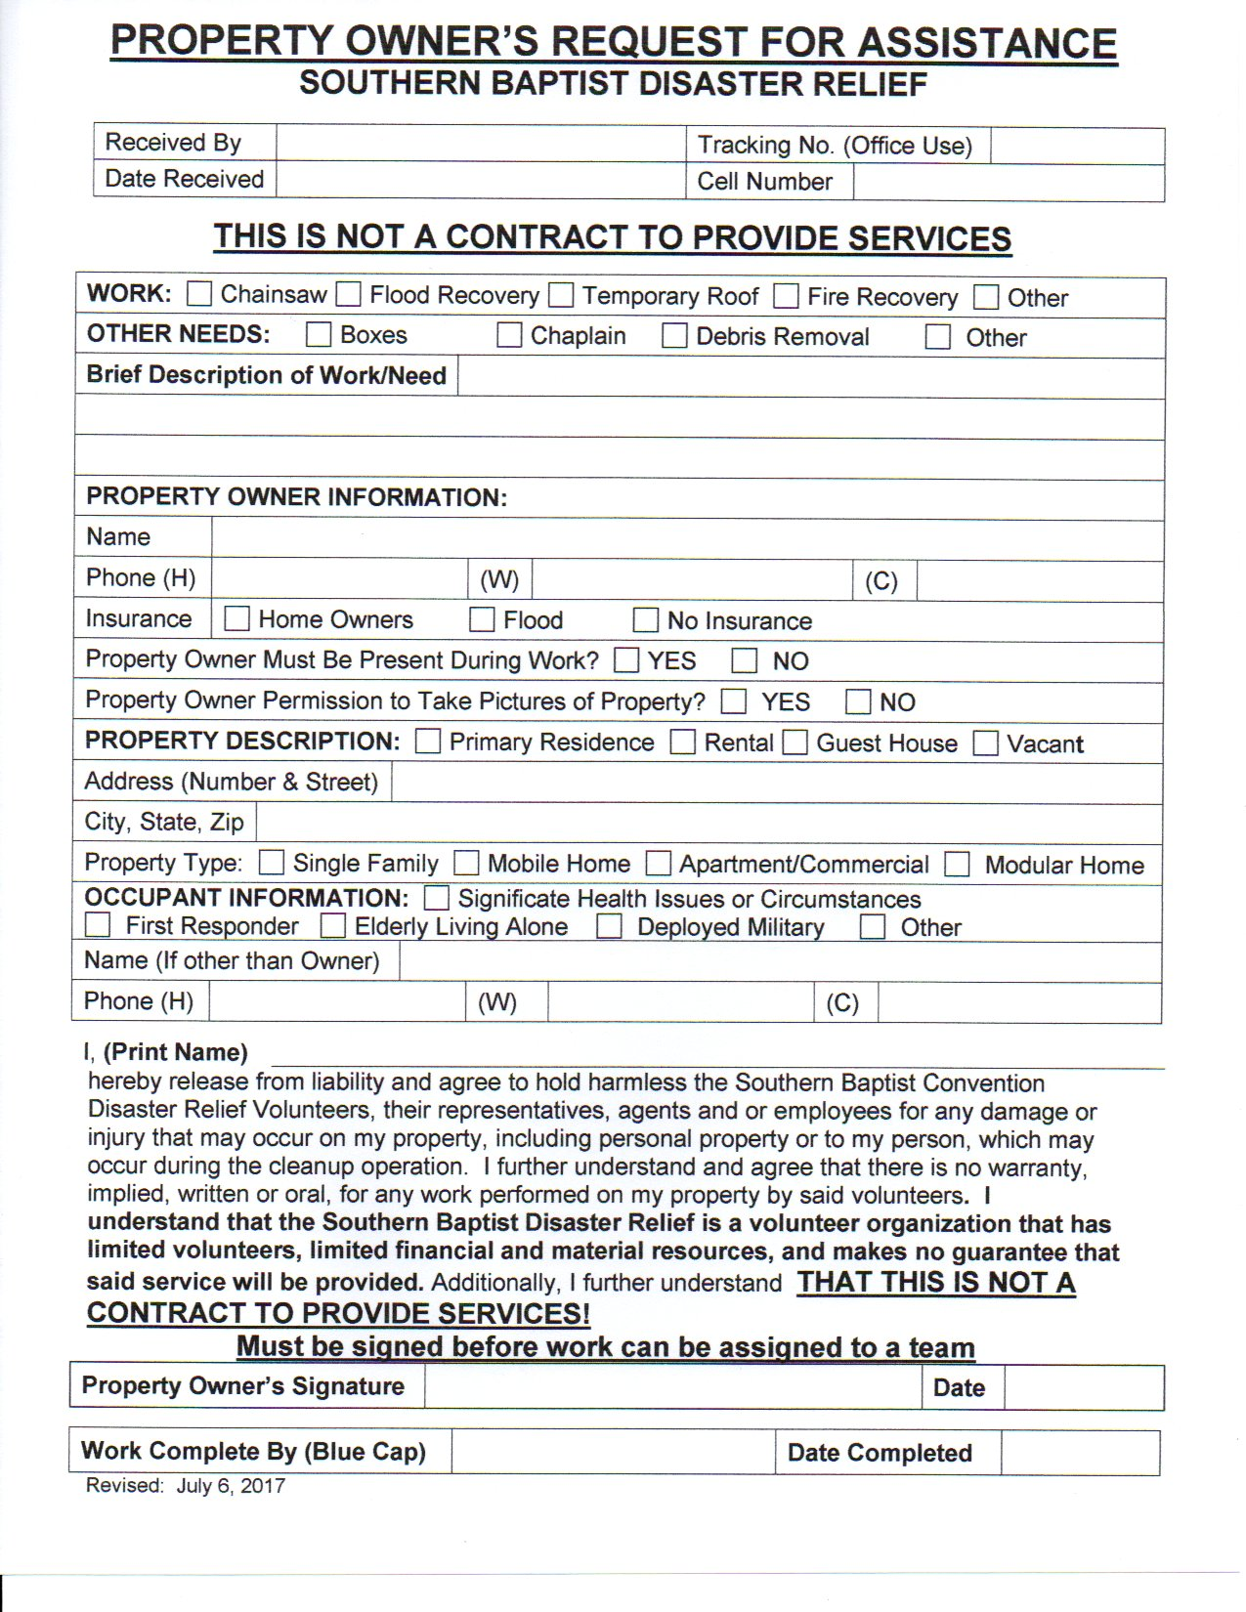

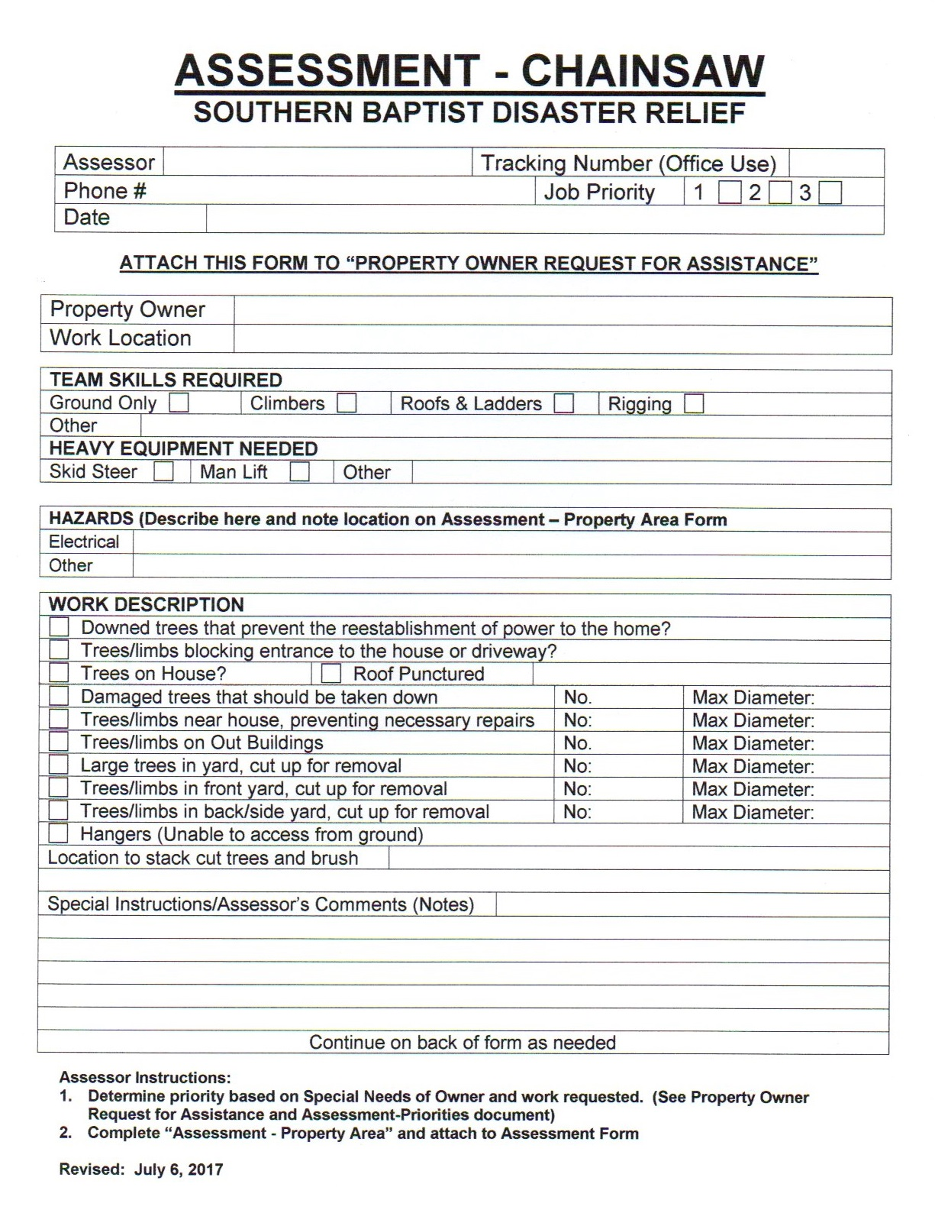

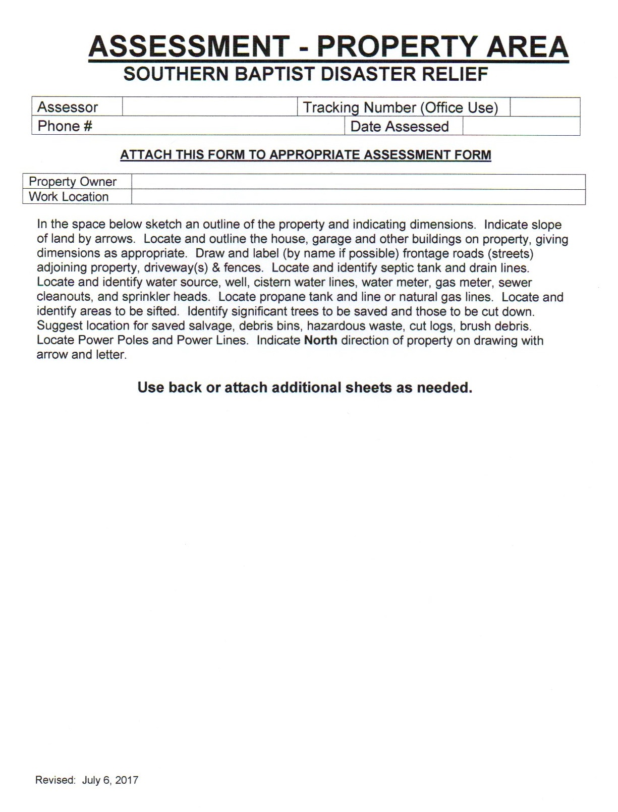

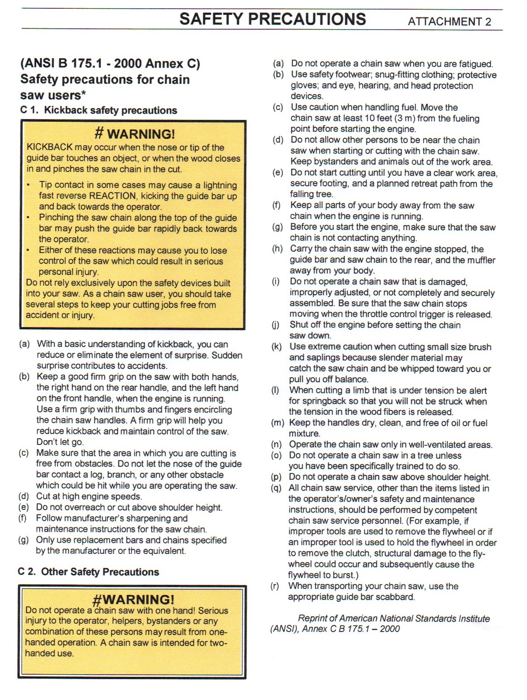

**ADDITIONAL NOTES**